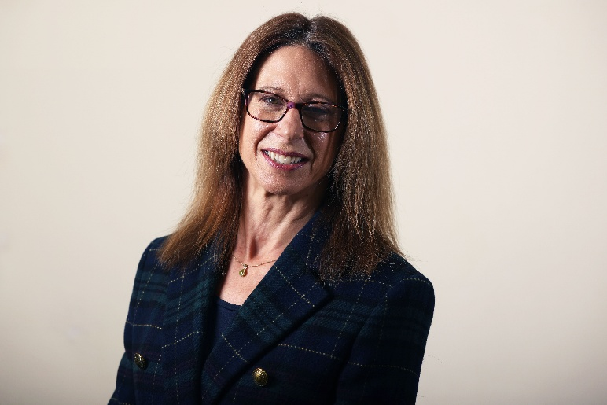
District Councillor Report
Haseley Brook ward
6th July 2026

Cllr Georgina Heritage
georgina.heritage@southoxon.gov.uk

Local Matters and what I’ve been doing

I’m sure that attending meetings was tough for everyone during the recent heatwave, and a few council meetings took place online, like the recent Health Improvement Board which I ended up chairing from my home office. However we’ve had a very busy Council and Cabinet month regardless, including a particularly weighty agenda on Thursday 2nd June. I would usually include details of this in the “Council Matters” section of my report, but I’m so excited about our decision to offer a business rates subsidy to South Oxfordshire pubs that I wanted to include it in my report as early on as possible!
This is a targeted, one-off reduction of 15% (over and above any government offer) to support our valued community hubs at a time when they are experiencing huge financial pressure. Pubs are important community spaces, valued rural assets and key contributors to the local economy and, having ran a pub myself, I know very well just how hard publicans work for their communities and the financial challenges they face. It’s even harder for pubs now than it was in my time and I was very happy to second this proposal, which has been carefully costed (and will not be funded through council tax).
Cabinet’s agenda also included my Social Cohesion Strategy as well as waste vehicle procurement policy and several other agenda items, and the agenda document pack can be viewed here: Choose agenda document pack - Cabinet 2 July 2026

There are lots of changes nationally in Planning, and councillors are in the process of receiving several officer briefings which will soon also be available for parish councils. This will include the changes to planning committee call-ins, which I emailed parish councils about last month. It’s still expected that this significant change will take effect from 31st October 2026.
I was asked at a parish meeting last month if the Government’s housing targets have affected the way planning officers make decisions. The answer is no – our local policies still stand and planning officers are able to refer to our emerging Joint Local Plan. However, it’s likely that we can expect more speculative applications, and appellants are quoting the new national targets in appeal situations, as I experienced at a recent hearing. There will be several opportunities for parish councils to take part in briefings and ask questions on planning very soon.
As I write, I have received no recent updates on local planning applications that we’ve been awaiting for some time. I left a message for the officer dealing with Postcombe and Lewknor solar farm to contact me on his return from annual leave. I have also been chasing up other applications which are taking longer than anticipated to reach a decision.
I’m aware that officers have to be careful not to refuse an application on the basis of an outstanding matter that could ultimately be resolved in an appeal situation. On one ongoing application, the planning officer worded his concern as follows:
“I am reluctant to refuse the application on the strength of the above objections, and trigger an expensive appeal process (most likely at a hearing), while there remains a possibility that the outstanding matters could still be resolved to the satisfaction of Thames Valley Police and OCC.
It's better to test all the evidence now, rather than have new evidence presented at an appeal, only for Thames Valley Police and OCC to remove their objections and for the council's case to fall over.”
District councils’ concern about appeals is not just the cost but also the threat of Designation by the government, if the number of a council’s appeals lost exceeds Government’s threshold. This happened to Cherwell Council recently, as you can read in this BBC report: https://www.bbc.co.uk/news/articles/ce958r4jmdpo

As I’ve also written about in my County report, I recently contacted TVP regarding the ongoing antisocial problem of noisy motorbikes which keep many of us awake at night in our local villages. I received the following response from a local officer, and I would encourage residents to keep reporting this nuisance so the police can build a case and take further action:
“As you mention, there is an ongoing issue with anti-social off-road motorbikes around Chinnor and the surrounding area, which we are aware of. I, along with the wider Thame Neighbourhood Police Team, will be the best policing point of contact for this. It’s a wider issue across the Thame Neighbourhood area with hotspots for similar anti-social behaviour around Wheatley, Barton and Shotover, and across the Thames Valley area in general.
When there was a spike in reported incidents a few months ago, we identified 3 of the lead persons involved and issued formal warning notices for anti-social use of a vehicle under Section 59 of the Police Reform Act 2002. Since then, there has been a downtick in reported incidents; within the past 2 weeks we have only received a single reported about the matter, which accounts for only 1 of 297 incidents reported to us in that time period.
Local officers remain aware of the issue and will stop check and conduct relevant enforcement actions on vehicles involved in the pattern of anti-social behaviour on patrol. However, in terms of a bidding for the assistance of specialist resources such as drones or pursuit trained units to assist in proactive enforcement attempts then we require evidence of significant ongoing community impact such as substantial quantities of reports indicating a community impact so as to persuade supervising ranks to allocate the necessary specialist resources and time. Unfortunately the number of reported incidents has declined from this threshold, and, whilst we suspect incidents are still occurring, without the statistical data to demonstrate this we have little prospect of receiving authorisation or support in proactive enforcement operations, nor would it be proportionate compared to other ongoing problems in the wider neighbourhood area.
We would encourage members of the community to continue reporting incidents when witnessed as it assists us in identifying peak times of incidents and hotspot locations to conduct intelligence-led patrolling and demonstrates that the pattern of anti-social behaviour is having a meaningful detrimental impact on the community.”

Finally, I enjoyed a lovely visit to Oxfordshire Animal Sanctuary last month, thanks to the SO Charitable Lottery. Each year, SODC distributes the central community fund from the SO Charitable lottery to the good causes selling 20 tickets a week or more at the end of the financial year. I’m really pleased that two good causes in the Haseley Brook ward – including Oxfordshire Animal Sanctuary - have been recipients again this year. I would very much encourage community organisations to consider selling SO Charitable Lottery tickets and for residents to support local good causes by purchasing tickets. More information about the lottery can be found here: SO Charitable Lottery - South Oxfordshire District Council

Council Matters

Final testing is being carried out on the new Land Charges system and unfortunately, due to the downtime, there is likely to be some catching-up time required at SODC. Further updates will be provided but please register for the new system by going to this page: South how to register

On Grants, please note that applications for the Capital Grant will close at midday on Monday 20th July. Applicants can request grants of a minimum of £5,000 and a maximum of £75,000 (no more than 50 per cent of the total project cost). Applications need to show how the project will help improve the quality of life for people in South Oxfordshire through projects that support thriving, healthy and inclusive communities, provide infrastructure that meets local need, that take action on climate change and nature recovery, and improve participation, accessibility and accountability.
Our Performing Arts Grant will open on the date that the Capital Grant closes – Monday 20th July – and will close on Friday 30th September This funding supports arts and community projects that give residents across the district the chance to take part in the performing arts, bringing communities together, improving wellbeing and helping grow South Oxfordshire’s arts scene.
Voluntary and community organisations can apply for grants of between £500 and £5,000, and funding can be used for projects such as festivals, concerts, dance lessons, accessible music sessions and equipment purchases. SODC’s Grants team is always happy to offer advice to applicants, and more information can be found via this link:
Performing Arts Grant Fund - opening 20 July 2026 - South Oxfordshire District Council

There are always local consultations that residents can take part in via Join the conversation - South Oxfordshire & Vale of White Horse - Citizen Space and there is currently a new public consultation on proposed changes to community governance arrangements in several towns and parishes across the district – including Great Haseley in the Haseley Brook ward.
Earlier this year, the council asked for views on a range of potential changes, including parish boundaries, the number of councillors and how local wards are organised. Following that initial consultation, the Community Governance and Electoral Issues Committee reviewed all feedback received and has now identified a set of final proposals to take forward.
Residents are now being asked to share their views on these proposals as part of a second consultation.
The consultation covers a range of recommendations across the district, including:
- Increasing the number of parish councillors for Ewelme and Stoke Row.
- Changes to parish warding arrangements for Didcot, Henley and Thame town councils.
- Amendments to parish boundaries between Shirburn and Pyrton, and between Thame and Great Haseley.
If the proposed changes are approved by the committee, the intention is that they would come into effect in time for the scheduled local elections in May 2027.
Community Governance Review in South Oxfordshire 2026 - Final Consultation on Proposed Changes - Join the conversation - South Oxfordshire & Vale of White Horse - Citizen Space

