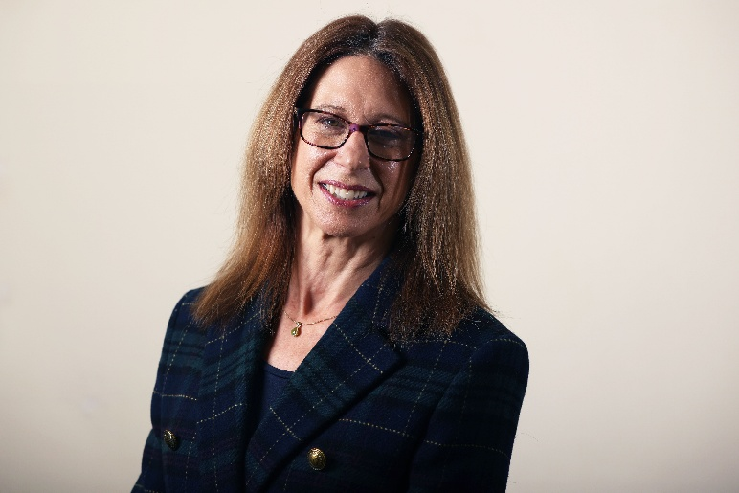
District Councillor Report
Haseley Brook ward
Annual Report May 2026

Cllr Georgina Heritage
georgina.heritage@southoxon.gov.uk

It continues to be a privilege to represent the Haseley Brook ward and I’m pleased to offer my annual summary of council activity over the past twelve months:

Since the government produced their local government reform white paper in December 2024, all council work has been against the backdrop of Local Government Reorganisation (LGR) and Devolution. The first part of Government’s programme is LGR, which affects counties like ours which operate under a two-tier system of District and County councils. All such councils are set to be abolished and, in their place, new unitary authorities. Government will decide on the size and shape of the new unitary council for our county, but affected councils throughout the UK were recently invited to submit a proposal. There are three proposals on the table for Oxfordshire. We’re still waiting for more information from Government on the direction for Oxfordshire and we expect news from the Ministry of Housing, Communities and Local Government before this summer’s parliamentary recess.
For councils’ “business as usual” activities, very few commitments can be made which take us beyond the next two years. This will inevitably present challenges. We want to be a council that gets things done and leaves strong legacies. However, whichever direction Government chooses for our county, it’s important that residents experience a smooth transition, and we are committed to working constructively on the process in order to achieve that.
What this means to residents in terms of the next local elections in 2027 is that we expect to be voting for a Shadow Authority – ie the councillors who will ultimately replace District and County councillors in 2028.

At SODC, our first full council meeting of the new council year in May 2025 saw us break our administrative partnership with the Green party. With new members joining the Lib Dem administration following district byelections, it was an appropriate time for the Liberal Democrat group to make a friendly and respectful break from our partnership with the Green party. We enjoyed working with the group and continue to do so, albeit from an opposition perspective.

In July 2025 the council was delighted to approve up to £10M towards approximately thirty homes for use as social housing, through an addition to the council’s approved capital programme. This funding was made available through money that had originally been earmarked for the proposed new building at the Gateway site in Didcot. Council approved the financial transfer and decision to cease to further work on this project in light of impending Local Government Reorganisation.

On 1st October the council received hugely disappointing news that South & Vale’s forward-looking Joint Local Plan was recommended for withdrawal over a single issue - “duty to co-operate”, specifically with Oxford City Council. It’s no secret that there’s disagreement within Oxfordshire on how many homes the rural districts should provide on Oxford’s behalf. Nevertheless, all councils in Oxfordshire are working towards what they believe to be in the best interests of their residents and their area.
The government later changed direction on this point and on 3rd December 2025 we were in a position to confirm to the Inspectors that we wanted to resume the local plan hearings. Government removed the “Duty to Cooperate” pass/fail test early in the new year, though cooperation would still need to be shown as part of the soundness test. The JLP Procedural Meeting took place on 12th February, and we are now set for the standard hearings which will be in the week commencing 6th July 2026. As an aside, unfortunately we’re already required to start working on a new Local Plan, due to the government’s new housing targets and NPPF, so that will no doubt be a topic for next year’s annual report!

February 2026 was Budget month for councils, and at SODC full council we approved a balanced “people first” budget for 2026/27, setting out plans to protect local services, invest in community facilities, provide affordable homes and manage public money carefully. I’m particularly proud of our community grant schemes which many councils are not in a position to offer. The latest budget includes:
- Funding for our leisure centres, including decarbonisation projects to reduce emissions and save energy.
- Significant commitment to investment in housing, which now totals £25 million, both for homelessness emergency accommodation and for those most in need on the housing register, in addition to financial support for community-led housing projects.
- New ongoing funding to support community cohesion, backing local projects that bring people together, reduce isolation and help strengthen community ties, particularly for vulnerable and marginalised residents. This is in addition to the council’s Community Hub, which will continue to help residents with housing issues, cost-of-living pressures and access to advice and support when they need it most.
- A record amount of grant funding at over £2 million, including £590,000 for community grants and £750,000 for infrastructure grants. This funding will help to deliver community-led projects such as village hall upgrades, improved facilities, energy efficiency projects and improvements to public spaces.
- Continuing to invest in climate action in a way that delivers real local benefits. A new £100,000 Climate Action Fund will accept bids for nature recovery and climate adaptation including flood alleviation and access to nature for local residents, while the council will continue to make its own buildings and facilities more efficient, helping to lower long-term running costs while also tackling climate change.
- Funding for the Wheatley flood alleviation scheme to help to protect at-risk homes and businesses.
- Funding to continue the council’s economic development work, helping businesses to start up, expand and adapt, supporting high streets, rural employers and the local economy more widely.
Residents pay an average £156.24 per year for services provided by SODC in 2026/27 - £3 per week - with its share of the council tax increasing by £5 a year for a typical Band D household. This small increase helps to protect frontline services and fund investment in local facilities, while ensuring the district’s council tax remains one of the lowest in the country.

Locally, I’ve been particularly active in planning matters over the past twelve months and have called several applications to planning committee hearings, where I’ve spoken on behalf of residents. The ward has experienced a difficult year with some large applications as well as enforcement matters to deal with. Like most residents, I understand our villages can’t stand still in time and we need housing for our younger generations. I’ve been supportive of many developments within the ward. However, quality of life is important and I don’t agree with housing estates without infrastructure. The new higher national housing targets may have changed the scene but I’ll continue to speak up for appropriate housing, not just any old housing, and to protect our village pubs and shops.
We still have some contentious applications and issues in the system, not all of which are housing developments, including the proposed Postcombe & Lewknor solar farm and the ongoing unauthorised traveller site enforcement case in Tetsworth, both of which I continue to liaise closely with parish councils and officers on.

One of the planning applications I’ve worked hardest on over the past 12 months involved the purchase of Haseley Industrial Estate by South & Vale councils, to be used as a depot for the districts’ waste vehicles. As it was the council’s own application it was not decided by an SODC planning officer but instead went to a cross-party planning committee in October 2025. I registered to speak as ward member and spoke on as many concerns as possible that residents had raised with me in correspondence, while focusing on the unsuitability of the A329 through Little Milton as a vehicle route. I had worked closely with County Councillor Judith Edwards and Freddie van Mierlo MP on this, including meetings with both OCC Highways and SODC officers prior to the committee date as well as research into local freight policy. We were relieved that our collaborative work - alongside the parish councils – resulted in traffic route conditions being imposed by committee members. Residents’ three main areas of concern – drainage, lighting and vehicle route management – were all addressed via amended conditions. The traffic route plan will be developed soon.
Works to the new depot have been slightly delayed due to nesting birds and bats, however I had the opportunity to visit the site recently and look at the works carried out so far. I learned more about the installed Sustainable Drainage Systems (SuDS) and the areas that attenuation has been introduced, and also that changes to the landscaping plan will result in deeper planting around the perimeter of the site – ie increased screening. In terms of the site work, I was pleased to learn that efficiencies on site are resulting in a 97% recycling rate.

In summary to this report, working as a local councillor is my full-time commitment and I always aim to be approachable and responsive, and to yield results and answers for residents. It is my job to represent you and I take this responsibility very seriously. If there’s anything about SODC that you’d like information about, or if I can be of assistance to you in any way, you are always very welcome to get in touch with me.

